MOSFET Amplifier for ECGR3131-001

RJ Jock, Jaskin Kabir

University of North Carolina Charlotte

[rjock@uncc.edu](mailto:rjock@uncc.edu), [jkabir@uncc.edu](mailto:jkabir@uncc.edu)

1. Introduction

For this project, a MOSFET amplifier had to be constructed that achieved a voltage gain of at least 10V and an output swing of 5V. The specifications also included the necessity of both +10 and -10 voltage sources. For these specifications, the common-source amplification circuit was chosen, as it offers the highest voltage gain out of the possible MOSFET amplification circuits.

1. DC Analysis

Before starting the DC analysis, a simulation was performed using Multisim to determine the appropriate resistance ratios and values to achieve maximum gain for the circuit. In the simulation, the circuit was constructed using 4 potentiometers seen in the figure below. This change allowed for much easier testing with the biasing conditions of the circuit, and for adjusting the resistance without having to end the simulation. In modification to the original specifications for the lab, the 2N7000 MOSFET chip was used instead, as the CD4007UBE is not included in the Multisim database and the two are functionally identical. Any differences in manufacturing specifications were noted and used during hand analysis.

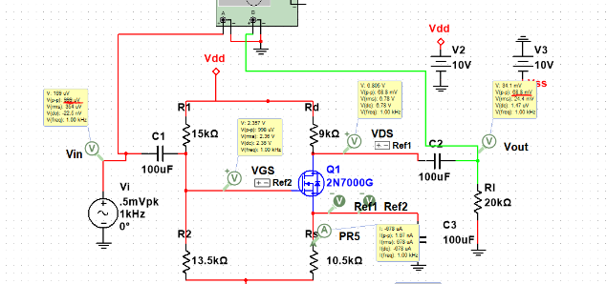

Figure 1 Simulated Common-Source Circuit

The simulation proved the following resistor values as optimal choices:

Once the resistor values were found, DC analysis was performed using standard biasing techniques for MOSFET amplifiers. As such, a 0V AC source was assumed, and so only the +10V and -10V DC sources contributed to the calculations.

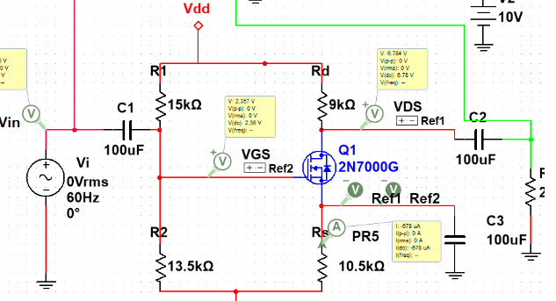

Figure 2 Common-Source Biasing Circuit

The equation for calculating the current across the drain branch ID is:

To solve for the drain current, the gate voltage must be calculated first. Knowing that gate voltage VG is equal to VDD – VR1, the equation could then be broken down as follows using voltage division:

Using this equation, the gate voltage was found to be -0.526V. Since IS=ID, the gate-source equation was then modified into mostly known values:

This allows for a substitution in the current equation ID so that the only unknown is the current itself. Completing the substitution for VGS in the voltage overdrive of the current equation leaves:

The value of kn and VT is given by the PSPICE model for the 2N7000, which is 0.0932A/V2 and 2.236V respectively. A substitution for V­G-VSS-VT is used with variable x to simplify the expression. The complete decomposition of the equation creates the polynomial:

Solving the polynomial in terms of ID gives two possible currents for the branch: 701µA or 677.8µA. The two current values were substituted back into the gate-source equation. For ID=701µA, the gate-source voltage is 2.113V which is not greater than the VT value of the MOSFET used. Therefore, the only valid ID value was 677.8µA.

To determine the drain-source voltage VDS, the equation can be broken down into the sum of the voltages across the branch:

By using this equation, the drain-source voltage is found to be 6.783V.

1. AC Analysis

To perform AC analysis on the amplifier, a small signal equivalent was used equivalent. This circuit is split into two main parts: input and output characteristics. Using this model, finding the input and output impedances is much simpler.

Figure Small-Signal Biasing Circuit

The transconductance gm can be calculated as which, using the values found during DC analysis, is equal to 0.0112. Since VGS= VIN during small-signal analysis, V­OUT can be characterized with the equation:

Then by dividing the equation by VIN, the gain can be calculated:

The input impedance rin is equal to R1||R2, so by using the existing resistor values the input impedance is equal to 7.105kΩ. The output impedance rout is similar, using the resistors RD||RL, resulting in a value of 6.207kΩ.

1. Results

|  |  |  |  |
| --- | --- | --- | --- |
|  | Theoretical | Simulated | Experimental |
| VGS (V) | 2.357 | 2.357 | 2.423 |
| VDS (V) | 6.783 | 6.784 | 6.873 |
| ID (µA) | 678 | 678 | 684 |

Table 1 Results of DC Analysis

|  |  |  |  |
| --- | --- | --- | --- |
|  | Theoretical | Simulated | Experimental |
| VGS (V) | 2.357 | 2.357 | 2.423 |
| VDS (V) | 6.783 | 6.784 | 6.873 |
| ID (µA) | 678 | 678 | 684 |

Table 2 Results of AC Analysis